**Real Time Early Diagnosis of Cognitive Impairment in Children Based on Eye Measurement**

**1Tarun Sarjana**

Department of ECE,

Institute of Aeronautical Engineering, T.S, INDIA

[tarunofficial.1309@gmail.com](mailto:tarunofficial.1309@gmail.com)

**2Ch. Tagore Rishil**

Department of ECE,

Institute of Aeronautical Engineering, T.S, INDIA

[tagorerishil7@gmail.com](mailto:tagorerishil7@gmail.com)

**3Tharun Singireddy**

Department of ECE,

Institute of Aeronautical Engineering, T.S, INDIA

[19951A04J7@iare.ac.in](mailto:tharunsagar9999@gmail.com)

**4Tharun Sagar**

Department of ECE,

Institute of Aeronautical Engineering, T.S, INDIA

[tharunsagar9999@gmail.com](mailto:tharunsagar9999@gmail.com)

**5 Dr. V Siva Nagaraju**

Professor of ECE,

Institute of Aeronautical Engineering, T.S , INDIA

[v.sivanagaraju@iare.ac.in](mailto:v.sivanagaraju@iare.ac.in)

**6Dr. D Srikar**

Assistant Professor of ECE,

Institute of Aeronautical Engineering, T.S , INDIA

[d.srikar@iare.ac.in](mailto:d.srikar@iare.ac.in)

1. **Abstract**

The unusual intent is that you will need a motion device that includes an advanced console. The number of people who have to move around with the help of some articles means illness. Also, by implementing a controller in it, you can get a license to ship without the help of others, which is very convenient. Anyway, the idea of ​​an eye examination that was overwhelmingly used to enter into a natural predestination that was even more markedly critical of being incompetent and debilitating. The camera takes pictures of eye development. First, find an eye job at the study center. Then, at this point, the rare sophomore variant gets an amazing sequence of computerized consoles. The alarm skips the main thrust of the engine and communicates with the advanced console itself. The engine's main thrust operates at any speed and course so that the computerized console can move forward, left, and stop properly. It uses a simple computerized digital camera to capture motion in real time, select jobs on a pixel-by-pixel basis, and assess the risk of illness early to identify intellectual weaknesses early. It will help.

**Keywords -** Facial expression analysis, camera capture

1. **Introduction**

At present situation paralyzed peoples need a guidance to do any work. One person should be they’re with that person to taken care of him. By using the eye ball tracking mechanism, we can fix the centroid on the eye based on the centroid we need to track that paralyzed human eye. This eye tracking engine includes many applications such as home automation and virtual keyboard applications that use a Python GUI to control robots.

Talking about illness, there is a saying that the eyes are the gate to one's soul and the witnesses for various internal cognitive or emotional processes. As examples one can note the detection of deception as part of hostile intention perception, the estimation of pain intensity via facial expression analysis, interpersonal coordination of mother-infant, assistance in marketing, and also contributions to early detection of impairments such as the ones related to children affected by autism, dyslexia or anxiety disorders.

1. **Literature Survey**

In the computer vision literature, the eye movements description divides the movement into saccades and fixations. Saccades are fast movements, with abrupt changes. They can be voluntarily produced but can also appear involuntarily. The gaze is fixed between saccades. Commitments last between 100 and 500 ms, whereas crackdowns can last from 30 ms for second-degree crackdowns to 50 ms for fifth-degree crackdowns. Fixations are measurements used in neuroscience and psychology to investigate the focus and the level of attention of the person.

Complaints of mental imbalance are presented using a guide on the use of weakened social communication, linguistic and nonverbal trade relationships, and devoted and boring behavior. Research requires explicit clinical evaluation with a talented professional usage guide, which usually results in inconsistent early-stage awareness. Various responses have been proposed, primarily depending on the current quality of the invention-filled and insightful PC, to assist in the procedure of the early character of mental imbalance. These studies relate to adolescent chemical imbalances, and the performance of tests on appearance type and eyes relies heavily on explicit mechanized estimates of perspective and subsequent vision. Experts have found that young people with mental imbalances look much less on the face or even on the eyes than normal people. Moreover, as the pictures show, they create a more prominent attachment, and they focus on lower capacity than objects. From a social point of view, they have much less eye contact and their ability to see corresponds to their verbal ability to act.

Another cognitive impairment closely related to the eyes and gaze tracking is dyslexia. Although less aggressive, dyslexia are more spread, being estimated to affect 10% of the human population. Early intervention is important to support children with dyslexia, so early diagnosis is mandatory. Many studies showed that dyslexic individuals exhibit abnormal gaze behaviour when tracking (longer duration of fixations and shorter saccades, leading to more fixations in notes).

1. **Existing Method**

MATLAB detects the iris and controls the cursor. Eye movement-controlled wheel chair is existing one that controls the wheel chair by monitoring eye movement**.**

1. **Problem defined**

In MATLAB is difficult to predict the Centroid of eye so we go for OpenCV. Techniques like electrooculography, infrared motion scanners, scleral coils have proven to solve these problems with 89% accuracy but the infra cost end is beyond the common use of public and still in progress. Any mechanical failure from these futuristic devices is difficult to identify and correct it as these are high gradable products and knowledge about these operations are limited.

1. **Proposed Method**

In our proposed system the cursor movement of computer is controlled by eye movement using Open CV. The camera detects eye movements that OpenCV can handle. By this the cursor can be controlled. This will help in understanding the movement of the eye in pixel ranges and at cursor point, that will further help in plotting a graph for manual correction. This help us detection of count of eye movements based of the given time period and estimate the medical parameters, if the person is suffering from cognitive disorders based on eye movements.

1. **Flowchart**

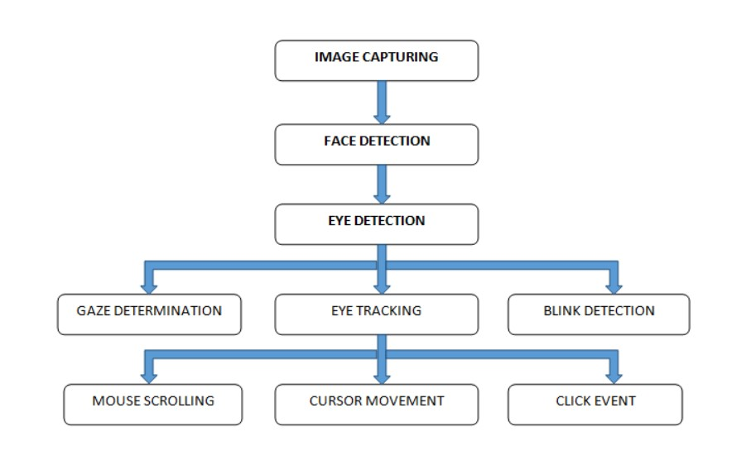

The user has to sits in front of the display screen of private computer or PC; A special video camera installed above the screen to study the consumer's eyes. The laptop continuously analyzes the video of interest and determines which display screen the consumer is calling. There is nothing attached to the consumer's head or body. To “pick out” any key, the user seems at the key for an exact period of time and to “press” any key, the consumer just blinks the eye. No calibration is required on this device. For this system, enter the simplest eye. No external equipment is connected or required. The camera receives a signal from the eye. When the camera receives these streaming movies, they go into frames. After receiving the frame, the camera checks the lighting conditions as it needs a sufficient number of fixtures from an external source. Otherwise, a message about a fatal error will appear on the screen. Captured frames that may already be in RGB mode are converted to black and white. five. Detects the iris of the eye (the center of the eye) by analyzing the picture (frame) from the source the eye is focused on.

After this, amid point is calculated through taking the suggest of left and right eye centre point. Eventually the mouse moves from one location to another on the display and the consumer clicks and blinks for 5 seconds. Instructs the mouse cursor to change position according to eye movement. This application uses OPENCV toconnect to webcam and then extract each frame from the webcam and pass to OPENCV to detect eye balls location. Once you find the position of the eyeball, you can extract the x and y coordinates of the eyeball from OPENCV and then use the python pyautogui API to tell the mouse to change its current position to the specified X and Y coordinates. eyeball. Here is an example of mouse movement in Python.

**Algorithm**

Face Detection/Eye Detection Using OpenCV

This seems complex at first but it is very easy. Let me walk you through the entire process and you will feel the same.

**Step 1:** Given the prerequisites, we first need an image. Later we need to create a cascading classifier that will ultimately provide the facial features.

**Step 2:** This step uses OpenCV to read images and function files. So I currently have a NumPy array at the underlying data points.

All we need to work is to search for the rows and columns values of the face NumPy N dimensional array. This is the array with the face rectangle coordinates.

**Step 3:** This final step involves displaying the image with the rectangular face box.

**pyautogui.moveTo(int(data_x),int(data_y))**

In above line moveTo function move cursor to given data_x and data_y location

1. **Block Diagram**

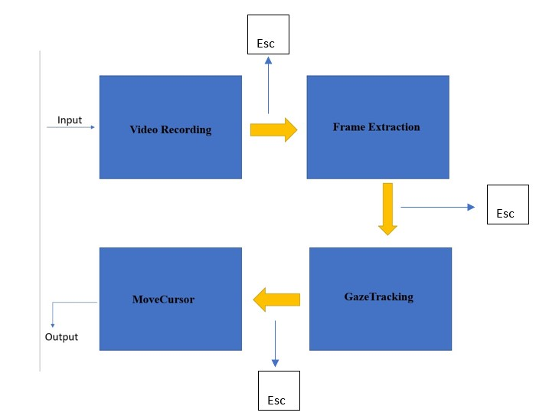

To implement above concept, we are using following modules

**Video Recording**: Using this module connect the app to your webcam using a built-in OPENCV feature called VideoCapture.

**Frame Extraction**: I am using this module to get frames from webcam, then extract each image frame by frame and send these frames to GazeTracking.

**GazeTracking**: You can use this module to detect the eyeball and extract the x and y coordinates of the left and right pupils.

**MoveCursor**: Use this module to tell the mouse to change its current position to a new position along the x and y axes.

To stop video recording from webcam press ‘Esc’ key.

OpenCV is an artificial intelligence API available in python to perform various operation on images/videos such as image recognition, face detection, eye detection/eye ball tracking and convert images to grey or coloured images etc. This API is written in C++ and then allows you to call C++ functions from Python using native programming. Steps related to face detection using OpenCV.

1. **Software used**

* Python
* OpenCV
* NumPy

1. **Source code**

EYE BALL CURSOR MOVEMENT USING OPENCV

**Step 1:** Given the prerequisites, we first need an image. Later we need to create a cascading classifier that will ultimately provide the facial features.

**Step 2:** This step uses OpenCV to read images and function files. So I currently have a NumPy array at the underlying data points.

All we need to do is to search for the row and column values of the face NumPy N dimensional array. This is the array with the face rectangle coordinates.

**Step 3:** This final step involves displaying the image with the rectangular face box.

**pyautogui.moveTo(int(data_x),int(data_y))**

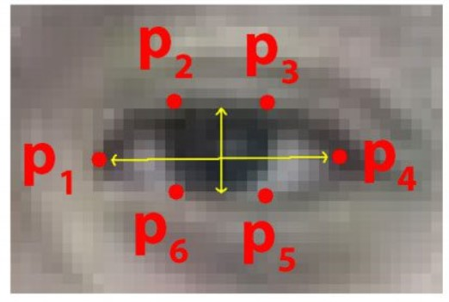In above line moveTo function move cursor to given data_x and data_y location

Gaze tracking using dlib _init_ commands and EAR formula

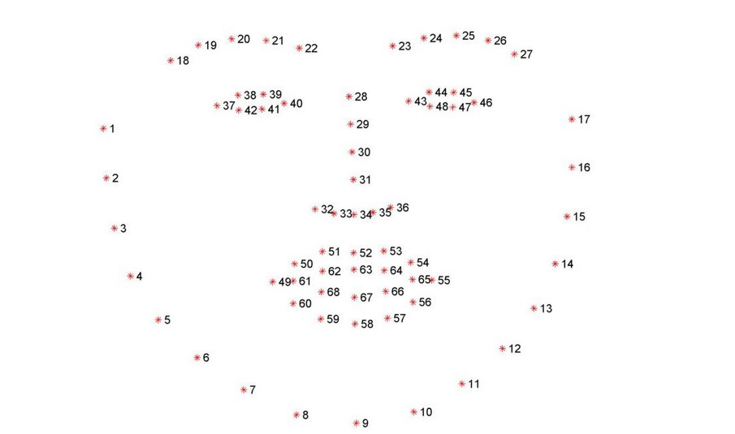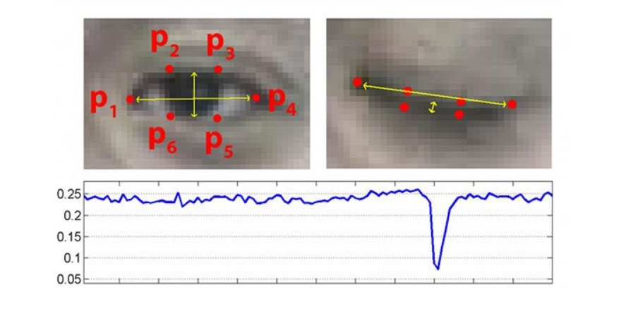

Face pattern recognition and eye ball tracking predefined dlib_init_ command using openCV

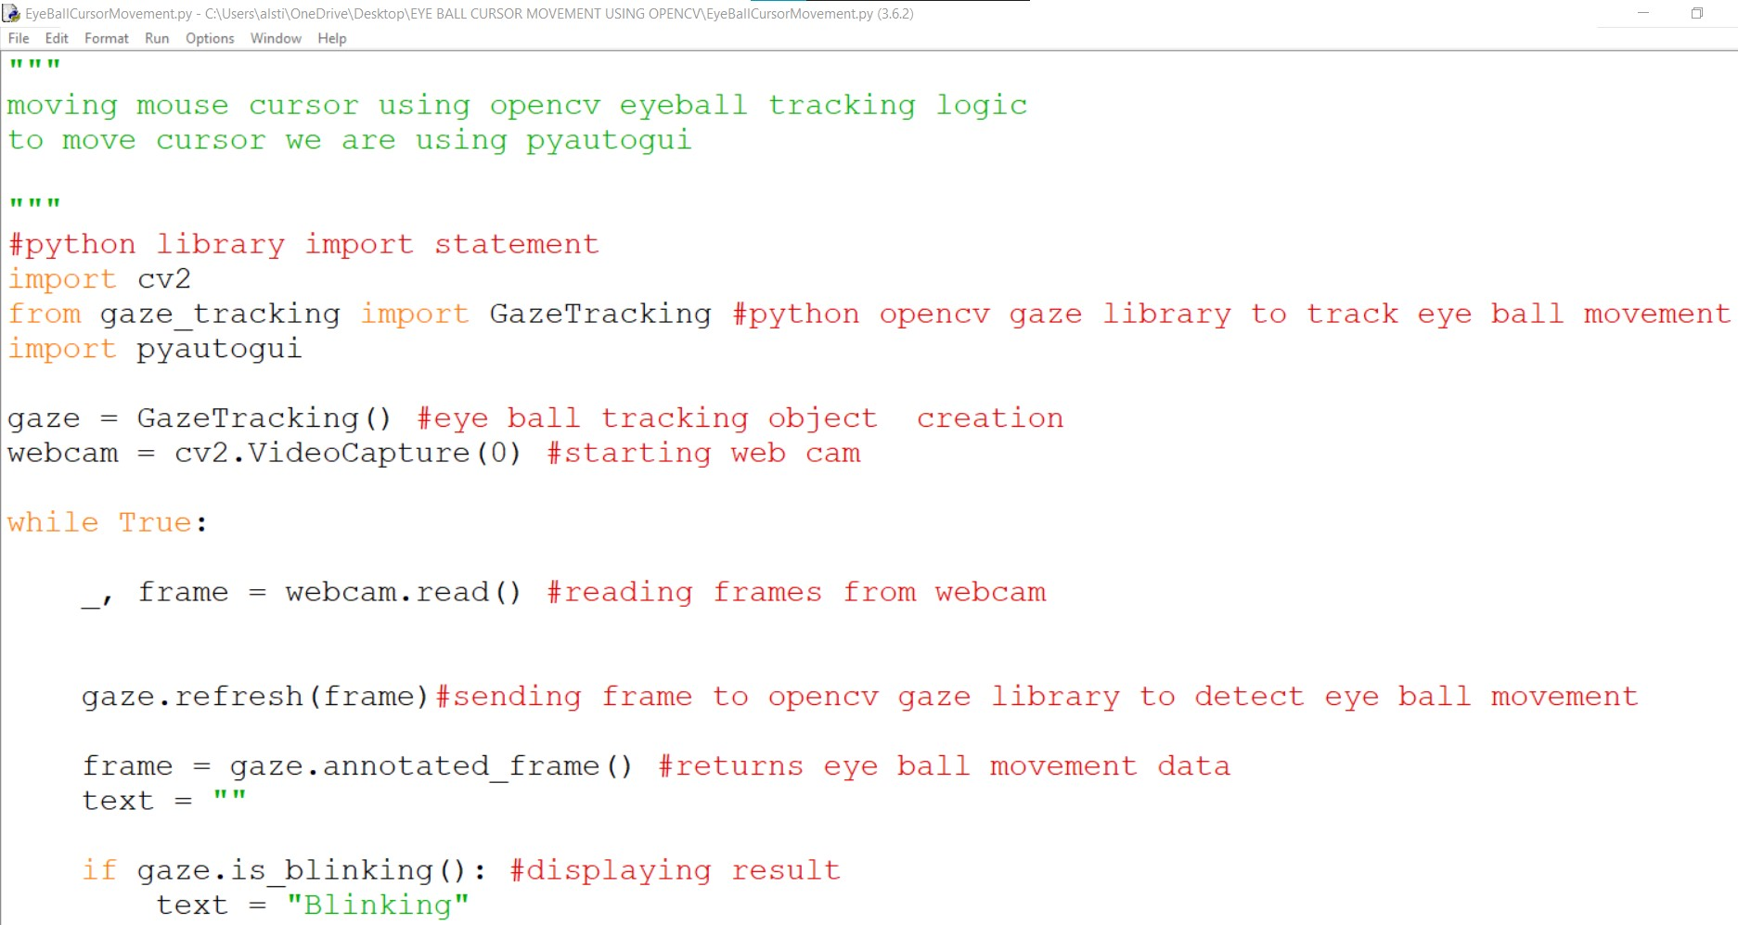

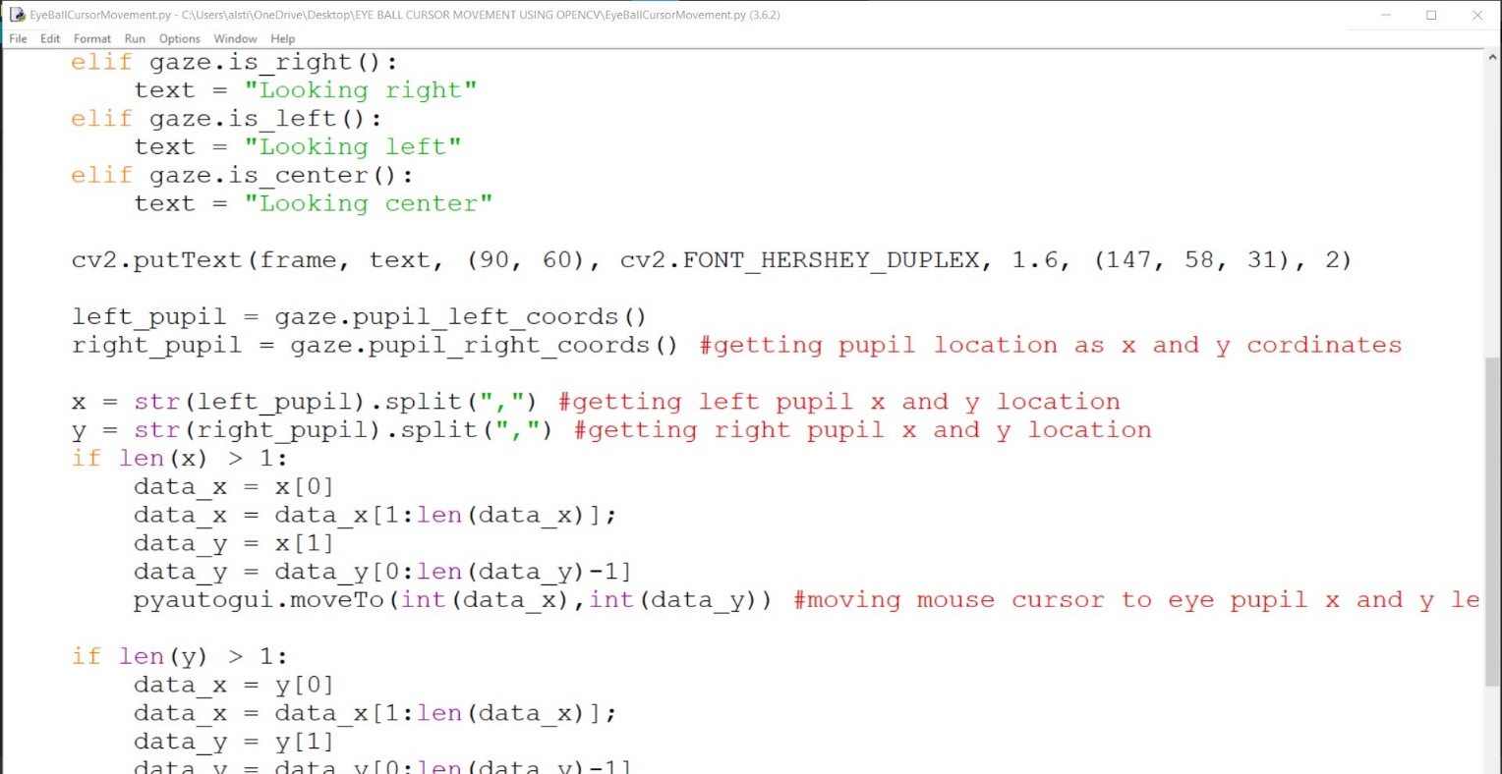

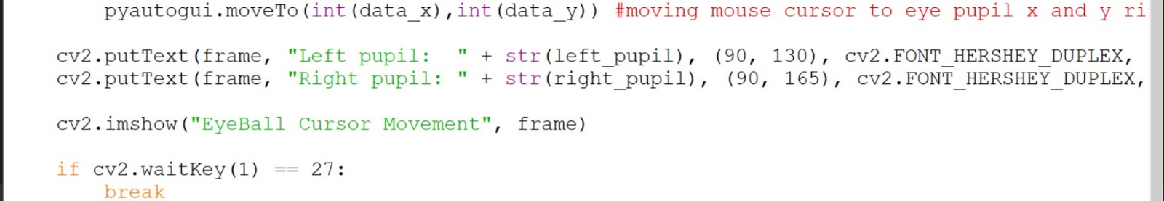

1. **Results and discussions**

The experimental results in this study provide objective evidence of eye tracking that supports the following hypothesis: the findings of existing research: Most students recognize beacons and pay more attention to these areas when debugging. Only significant statistical results have been reported in the conclusions, guaranteeing the conclusion validity. Previous research has revealed a relationship between working memory capacity and the cognitive activities related to debugging with regard to mental arithmetic, short-term memory, logical thinking, and problem solving. Thus, the eye ball movement tracking is applied to physically challenged peoples to obtain various results.

Learning about EAR(Eye Aspect Ratio),function of dlib and OpenCV which introduces machine learning techniques and also facilitates to learn the functional model of an eye and analyse its pattern of movement to determine the illness triggering mental disorders. This tool can predict with accuracy to 80% and can also help physically handicapped people.

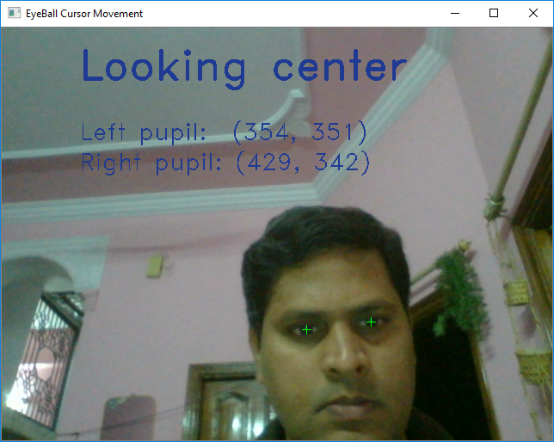

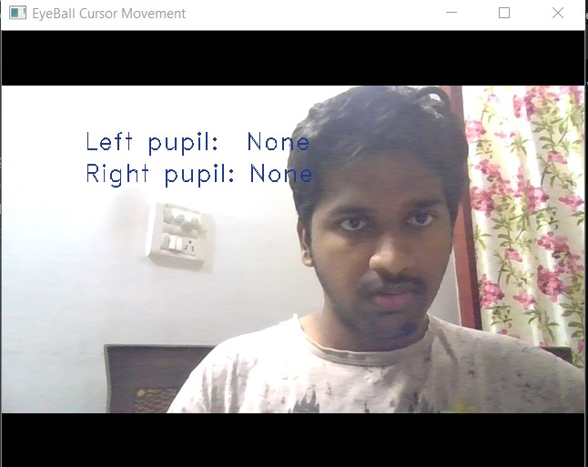

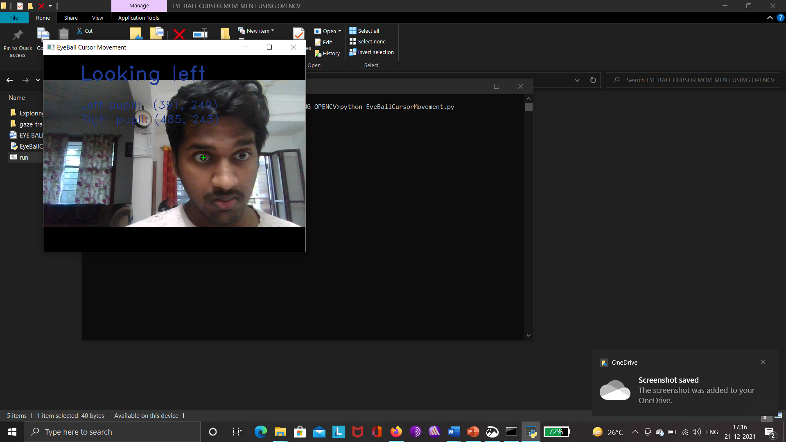

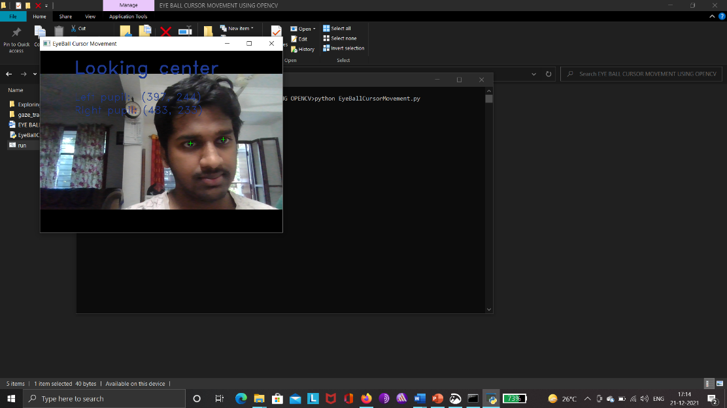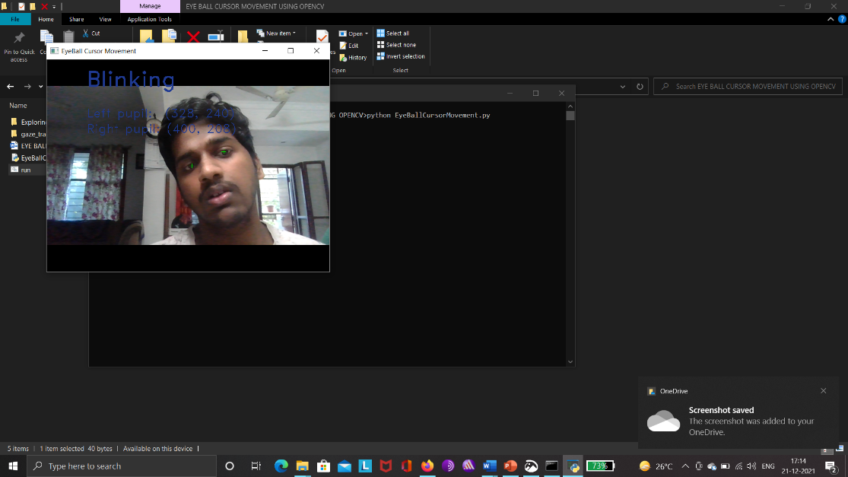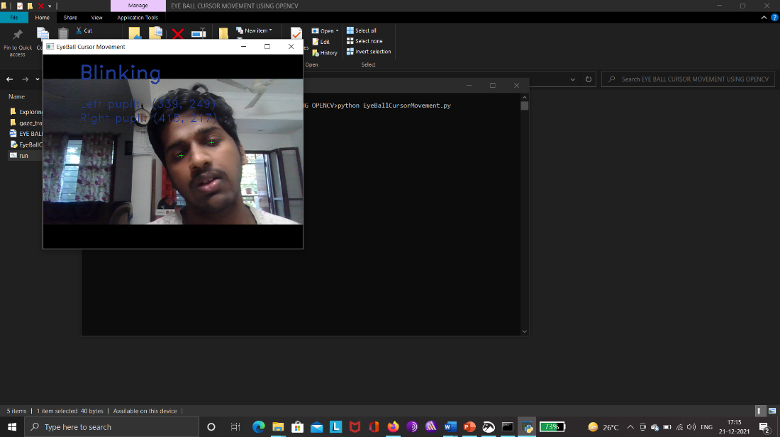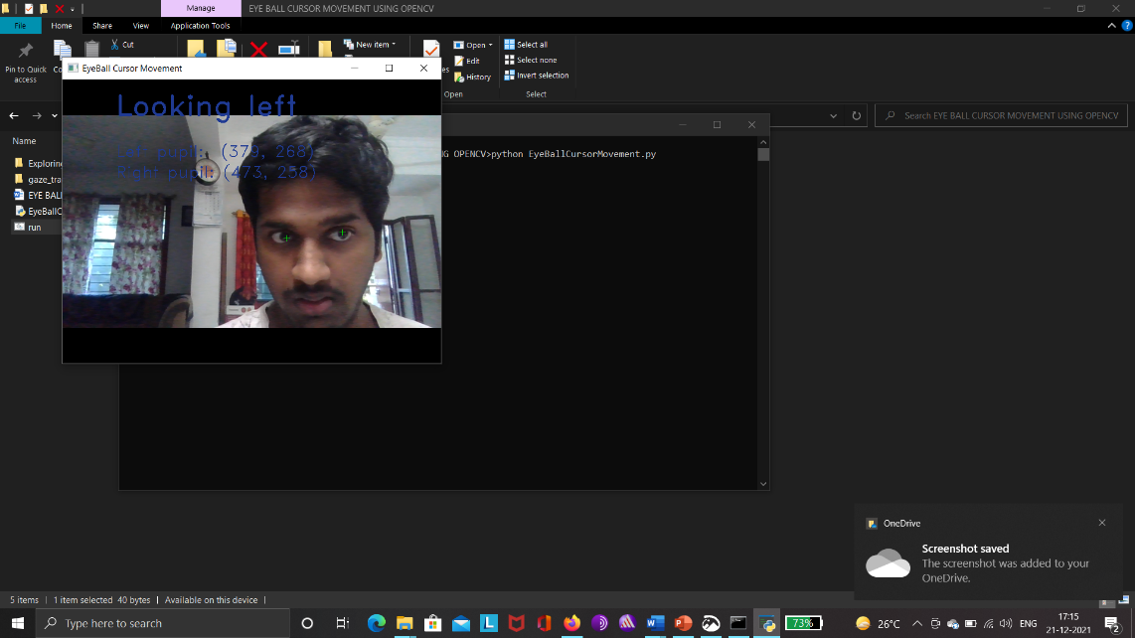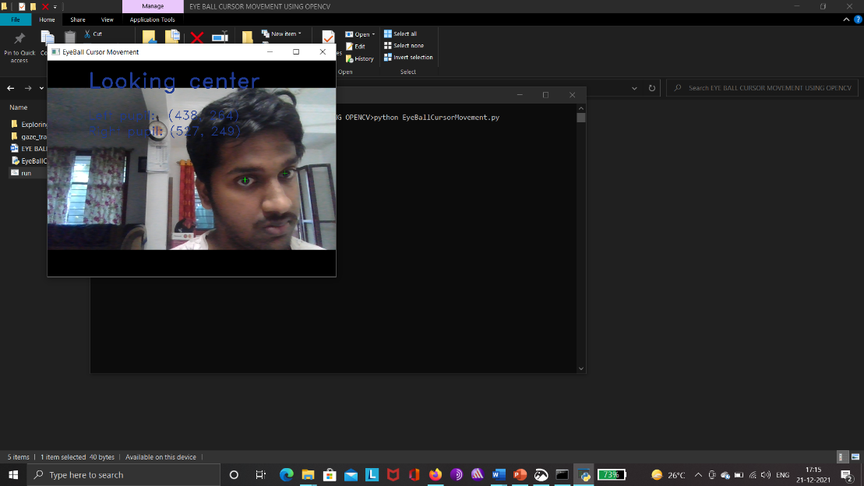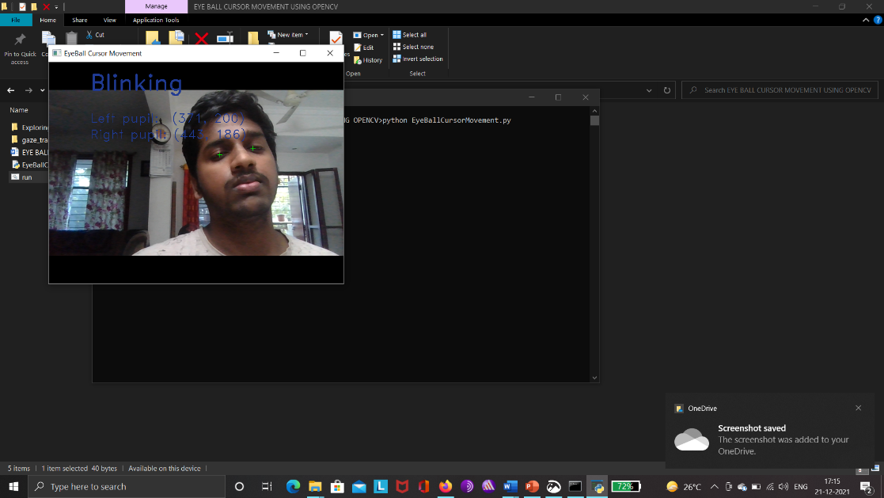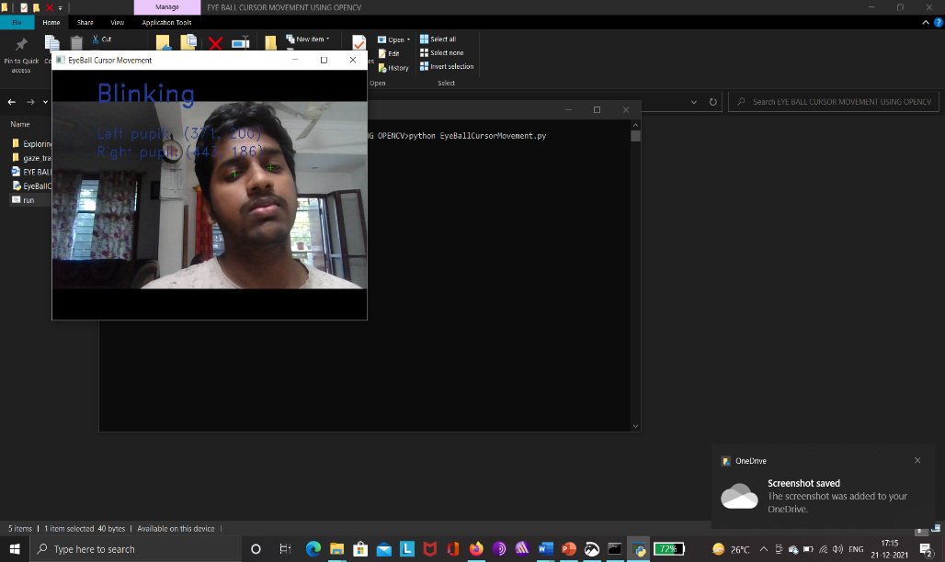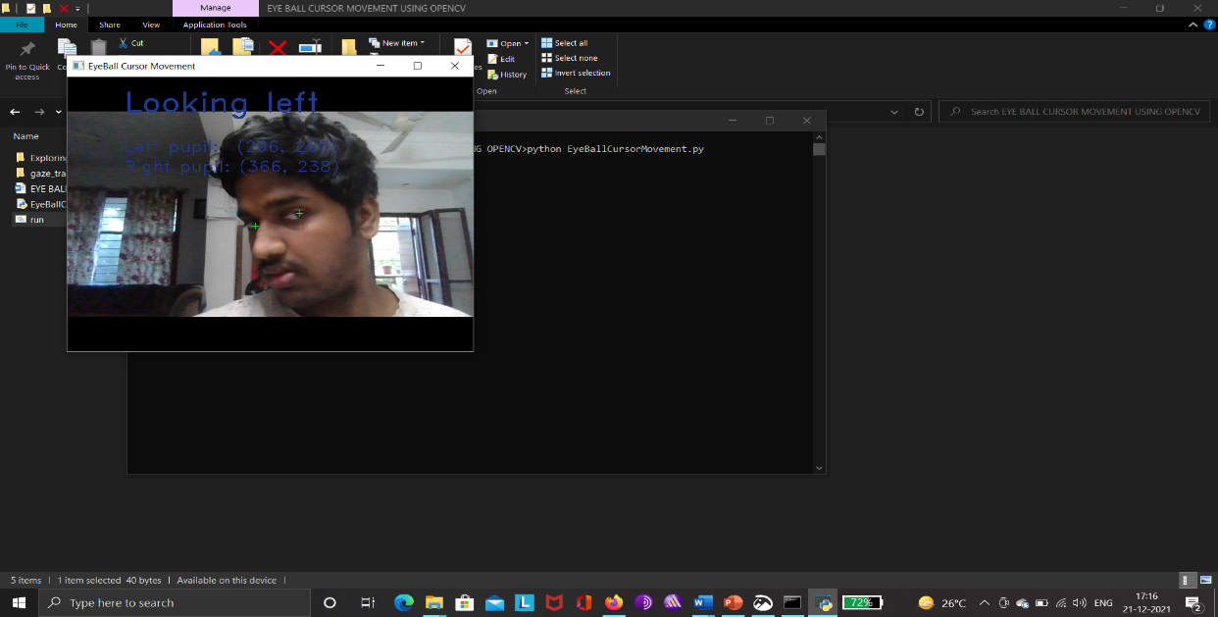

In above screen you can see cursor moves based on eye ball movement. Exception will raise and window close if u move cursor close corners of the screen. Number of blinks will be calculated manually from the supposed samples for a minute time and count the accuracy. Average healthy human eye can blink 15-20 times. Autist and dyslexic people differ these abnormally than this ranges.

1. **Future Scope**

Increasing the accuracy to .8% higher to make this tool alternative and most wide end use to psychological electronic measurmentation aid.

1. **References**

[1].Brooks,R.E.(1997) ―Towards a theory of the cognitive processes in computer programming,‖ Int. J. Man-Mach. Studies, vol. 9, pp. 737–751.

[2].Cheng- Chih Wu, Ting-Yun Hou(2015)‖Tracking Students’ Cognitive Processes During Program Debugging‖—An Eye-Movement Approach, IEEE.

[3].Ehrlich,K. and Soloway,E.(1983) Cognitive strategies and looping constructs: An empirical study,‖ Commun. ACM, vol. 26, no. 11, pp. 853–860.

[4].Eric Sung and Jian-Gang Wang (2002)―Study on Eye Gaze Estimation‖, IEEE, VOL. 32, NO. 3, JUNE .

[5].Murphy,L. (2008)―Debugging: The good, the bad, and the quirky—A qualitative analysis of novices’ strategies,‖ SIGCSE Bull., vol. 40, no. 1, pp. 163–167.

[6].QiangJi and Zhiwei Zhu (2007)‖Novel Eye Gaze Tracking Techniques Under Natural Head Movement‖, Senior Member, IEEE, VOL. 54, NO. 12, DECEMBER

[7] D. W. Hansen and Q. Ji, “In the eye of the beholder: a survey of models for eyes and gaze,” IEEE Trans. Pattern Analysis and Machine Intelligence, vol. 32, no. 3, pp. 478- 500, Mar., 2010, doi: 10.1109/TPAMI.2009.30.

[8] W. Jones, K. Carr, and A. Klin, “Absence of preferential looking to the eyes of approaching adults predicts level of social disability in 2-year-old toddlers with autism spectrum disorder,” Archives of General Psychiatry, vol. 65, no. 8, pp. 946-954, Aug., 2008, doi: 10.1001/archpsyc.65.8.946.

[9] S. Wang et al., “Atypical visual saliency in autism spectrum disorder quantified through model-based eye tracking,” Neuron, vol. 88, no. 3, pp. 604-616, Nov., 2015, doi: 10.1016/j. neuron.2015.09.042.

[10] J. Rehg et al., “Decoding children's social behavior,” in Proc. of IEEE Conf. on Computer Vision and Pattern Recognition, pp. 3414–3421, 2013, doi: 10.1109/CVPR.2013.438.

[11] T. Falck-Ytter, S. Bolte, and G. Gredeback, “Eye tracking in early autism research,” J. Neurodevelopmental Disorders, vol. 5, no. 28, Sep. 2013, doi: 10.1186/1866-1955-5-28.

[12] C. Prado, M. Dubois, and S. Valdois, “The eye movements of dyslexic children during reading and visual search: impact of the visual attention span,” Vision Research, vol. 47, no. 19, pp. 2521- 2530, Sep., 2007, doi:10.1016/j.visres.2007.06.001.

[13] M. N. Benfatto, G. O. Seimyr, J. Ygge, T. Pansell, A. Rydberg, and C. Jacobson, “Screening for dyslexia using eye tracking during reading,” PLOS ONE; vol. 11, no. 12, pp. e0165508, Dec., 2016, doi:10.1371/journal.pone.0165508.